GAME SHEET PRINTING

To login, please go to SDCSL webpage www.sdcsl.com and click on the Manager Login link
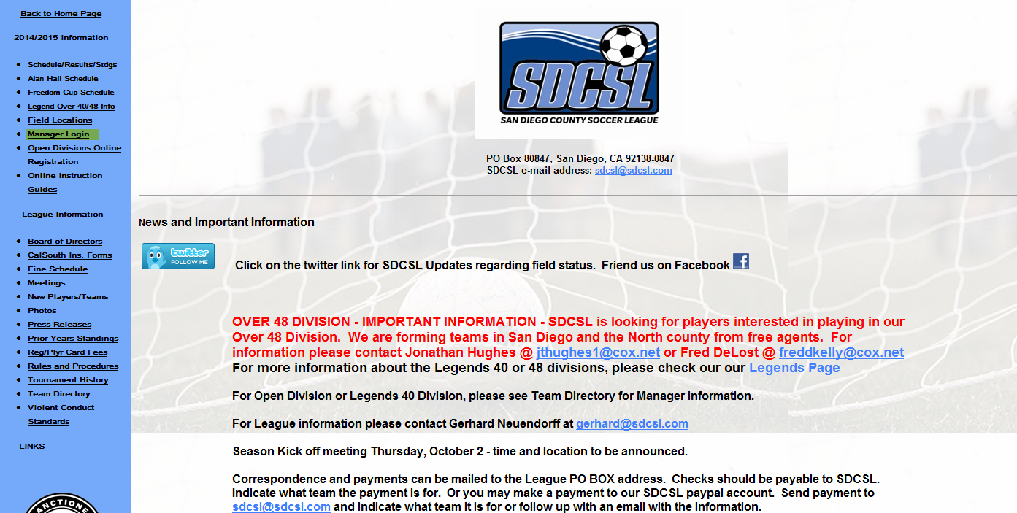
Enter your Username and Password for your manager account. This is the account you use also to register players to your team.
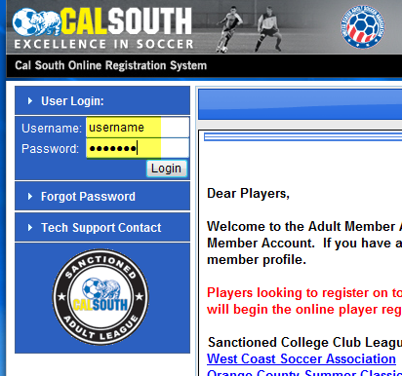
Once logged in, go to the Tournament Applications/Game Scoring Section. There you will see your team name and the 2015 San Diego County Soccer League listed. To the right click on the Schedules/Game Scoring Link.
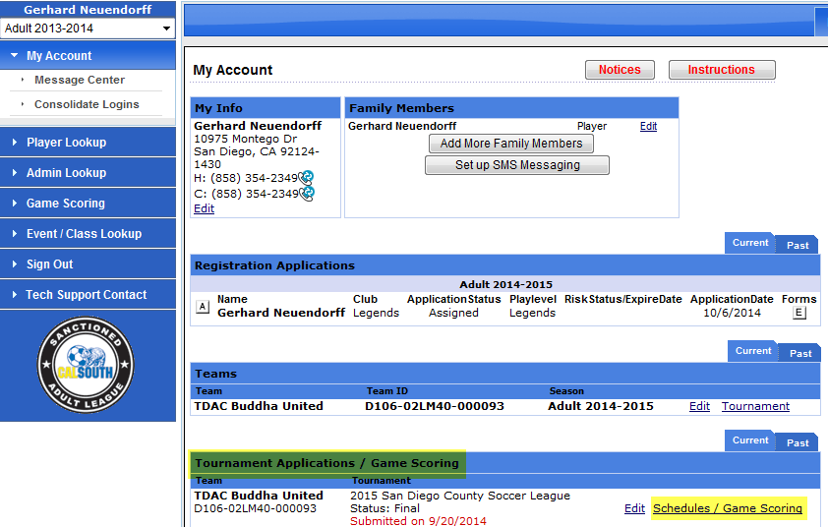
You will now see the standings and below that the schedule for your team. Each week the Print Roster button will become available to print starting 4 days prior to the game. We suggest you do not print rosters until the weekend as your opponent may change their line up. Click on the Print Roster button.

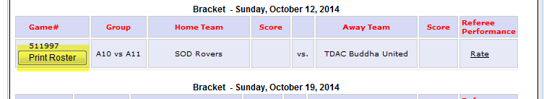

After clicking on this your game sheet will appear in a new window. Click on File/Print. Make sure to print both pages as there is one page for each teams roster. In addition, prior to printing your game roster, if you have more than 22 players on your team roster, you need to make sure you set the 22 players you want active for that game. Please see other instructions for the process to set players active.
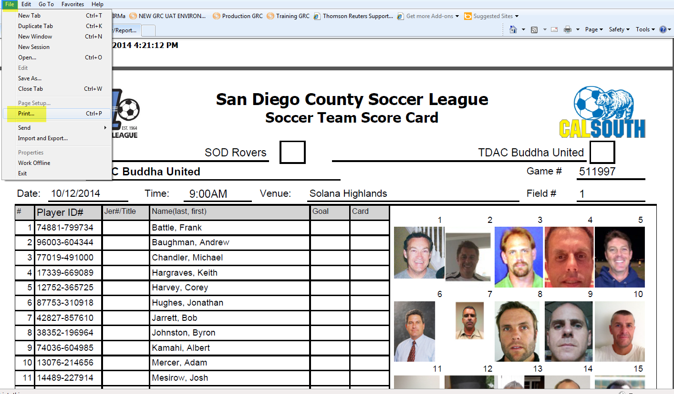

GAME SCORING
To input your score after your game is completed, please click on the Schedules/Game Scoring link
Then Click on your teams score window. This will open up a scoring window for you to populate with goal/caution/ejection information.
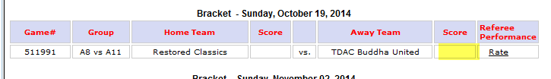
Once you click on your teams score window the following screen appears.
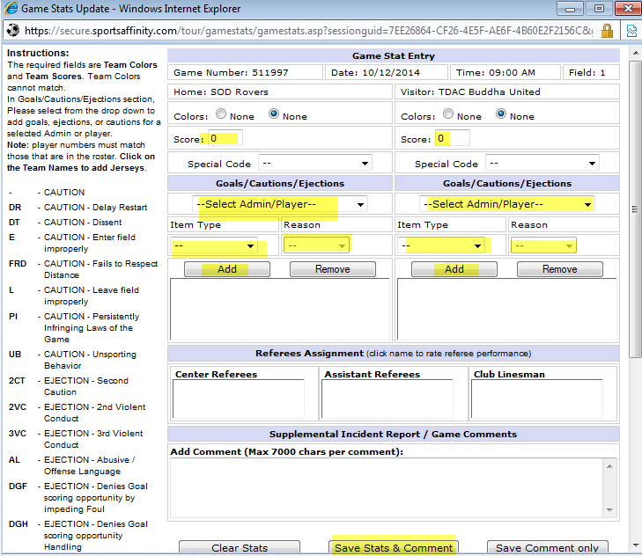
Make sure to input all pertinent information for goal scorers and cautions, ejections for both teams. This is why it is important to confirm with the referees and other team manager that all information is accurate. If you select Caution, please make sure to input the reason (UB for Unsporting Behaviour, PI for Persisten Infringement, etc…The referee should put the code down. If it is a red card, indicate what code also, i.e. 2CT means double caution/yellow, VC is Violent Conduct, SFP, etc…) When completed press the Save Stats button.

